LAB 3 ASSIGNMENT

INFERENCES FOR CATEGORICAL DATA

In this lab assignment, you will apply the descriptive and inferential tools in StatCrunch to explore the survival of a group of American pioneers who migrated by wagon from Illinois to California in 1846 and were trapped by heavy snowfall in Sierra Nevada Mountains. You will analyse the survival of the group members in terms of age, sex, and the kin group with which each member travelled.

In particular, you will display and summarize the related categorical variables and explore the relationship between them with contingency tables. Tests and confidence intervals for proportions will be used to compare the survival rates in selected groups. Before you start working on the assignment, you should review the course material about categorical data and get familiar with Lab 3 Instructions.

The Donner Party: Natural Selection in Action

The Donner Party is the name of emigrants who travelled in covered wagons from Illinois to California in 1846 and became trapped in the Sierra Nevada Mountains when the region was hit by heavy snows in late October. By the time the survivors were rescued in April, 1847, 40 out of 87 had died from famine and exposure to severe cold. Some of those that survived did so by resorting to cannibalism according to newspapers reporting at that time. Data on the survivorship of the party members may be used to gain some insight into human behavior and natural selection under extreme stress. For example, some questions of interest are whether males are better able to withstand harsh conditions than females and the extent to which the chances of survival vary with age.

The data in the lab assignment come from Grayson, (1990), “Donner Party Deaths: A Demographic Assessment,” Journal of Anthropological Research, v.46. The data are also available in the StatCrunch file lab3.txt located on the STAT 151 Laboratories web site at http://www.stat.ualberta.ca/statslabs/stat151/index.htm (click Stat 151 link, and Data for Lab 3). The data are not to be printed in your submission. The following is a description of the variables in the data file:

Variable Name Description of Variable

NAME full name of the passenger,
GENDER gender (female or male);
FAMILY family name,
POSITION member status within the family,
AGE estimated age (in years) as of July 31, 1846;
CHILD child (yes or no)
SURVIVAL survived or died,
ORDER order of death,
DATE date of death,
ALONE Yes if travelling alone (no family, no close accompanying persons),
GROUP SIZE Number of group members.

Use the data to answer Questions 1-7.

- Is it an observational study or a randomized experiment? Can the data be generalized to a broader population? If females in the study turned out to be more apt to survive than males, could this be used as proof that in general females are better able to withstand harsh conditions than males?

There are no treatments imposed on the subjects in the study. Their fate in the ordeal (survival or non-survival), age, position and family membership are recorded for each subject. Therefore, the study is an example of an observational study. No causal inferences about survival can be made based on the data.

Since the 87 individuals were not drawn at random from any well-defined population, inference to a broader population is not justified. Moreover, as the study is observational, the results cannot be used as evidence that females were more likely to survive than males; some confounding variables can be responsible for difference if any.

- Now discuss the data in the file. How many cases are there? Identify categorical and numerical variables in the data.

There are 87 cases in the data file. There is one identifier variable, Name and two numerical variables, Age and Group Size. There are four categorical variables, Family, Position, Child, and Alone. Order is an ordinal variable.

- Now you will use frequency tables to summarize the family and gender composition of the group and obtain the proportions of group members who survived for each family and gender.

- What was the overall survival rate? Obtain the appropriate frequency table to answer the question and paste the table into your report.

Frequency table results for Survival:
Count = 87
Survival | Frequency | Relative Frequency | Percent of Total
Died | 40 | 0.45977011 | 45.977011
Survived | 47 | 0.54022989 | 54.022989

47 out of 87 people survived the ordeal. Proportionally, 54% survived and 46% died.

- Which family lost proportionally more members than others? Obtain the appropriate frequency table to answer the question. Do not paste the output into your report.

In order to answer the question, frequency table of survival by Family has to be obtained. The families that proportionally lost most of their members are the Eddys (75% died, 3 out of 4), the Kesebergs (66.7% died, four out of 6) and the Wolfingers (66.7% died, two out of three).

- What was the survival of people travelling alone and that of those travelling with their families or spouses?

Frequency table results forSurvival:
Group: Alone=No
Count = 71
Survival | Frequency | Relative Frequency | Percent of Total
Died | 27 | 0.38028169 | 38.028169
Survived | 44 | 0.61971831 | 61.971831

Frequency table results for Survival:
Group: Alone=Yes
Count = 16
Survival | Frequency | Relative Frequency | Percent of Total
Died | 13 | 0.8125 | 81.25
Survived | 3 | 0.1875 | 18.75

There is a large difference in the survival rates between people travelling alone (Teamsters, Vaqueros and Passengers) and people travelling with their spouses or families. The survival rate for people travelling alone is 18.75% versus 63.38% travelling with spouses or families.

- What percentage of each gender group survived the ordeal? Obtain the appropriate relative frequency table (Frequency, Relative Frequency and Percent of Total) to answer the question. Paste the table into your report. Moreover, obtain the corresponding bar chart of survival by gender (separate graph for each gender). Paste the two charts into your report. Comment briefly.

Frequency table results for Survival:
Group: Gender=Female
Count = 34
Survival | Frequency | Relative Frequency | Percent of Total
Died | 10 | 0.29411765 | 29.411765
Survived | 24 | 0.70588235 | 70.588235
Frequency table results for Survival:
Group: Gender=Male
Count = 53
Survival | Frequency | Relative Frequency | Percent of Total
Died | 30 | 0.56603774 | 56.603774
Survived | 23 | 0.43396226 | 43.396226

According to the output, 70.6% of females survived versus 43.4% of males. The survival rate for females was substantially higher than the survival rate for males. It would appear that being female made it more likely to survive the ordeal. Under conditions marked by famine and extreme cold in the study, females fared better than their male counterparts. As the data are observational, the differences in the mortality rates between the two genders cannot be attributed to gender alone.

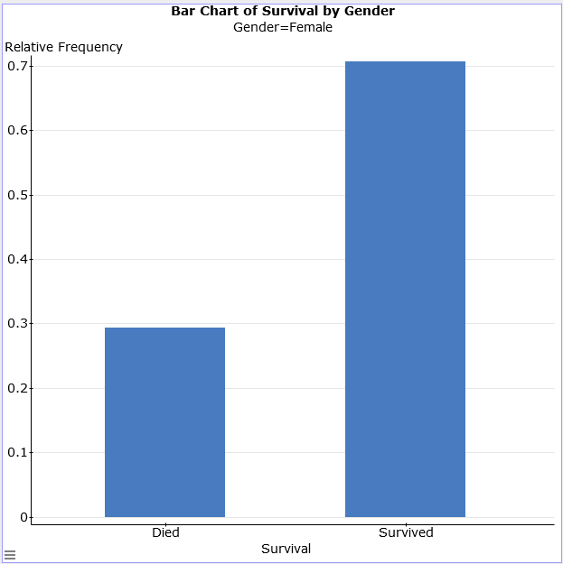

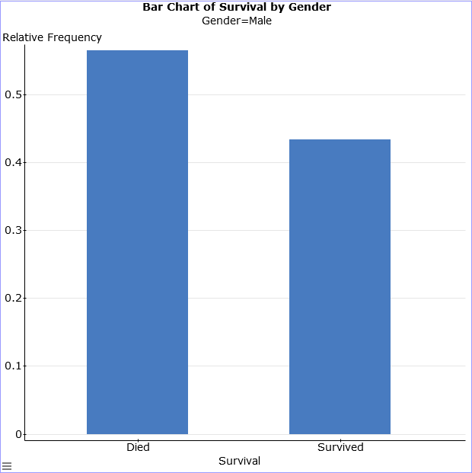
- Compare the survival of children with that of adult party members. Paste the appropriate output into your report. Comment briefly.

Frequency table results for Outcome:
Group: Child=No
Count = 41
Outcome | Frequency | Relative Frequency
Died | 25 | 0.6097561
Survived | 16 | 0.3902439

Frequency table results for Survived:
Group: Child=Yes
Count = 46
Outcome | Frequency | Relative Frequency
Died | 15 | 0.32608696
Survived | 31 | 0.67391304

Children were much more likely to survive. The survival rate for children was 67.4% versus 39% for adults.

- Obtain the summary statistics of age (mean, median, standard deviation and the interquartile range) for survivors and non-survivors. Paste the output into your report. Moreover, obtain the side-by-side boxplots of age for survivors and non-survivors. Use fences to identify outliers. Paste the boxplots into your report. Comment about the medians, shapes and spreads of the two distributions.

Summary statistics for Age:
Group by: Survived
Survived | n | Mean | Std. dev. | Median | IQR
Died | 40 | 23.6 | 18.005412 | 25 | 29
Survived | 47 | 16.319149 | 11.62289 | 14 | 15

According to the summary statistics and the boxplots, those who did not survive tended to be older than those who survived. Survivors were on the average 7.3 years younger than non-survivors. The difference in the medians is even more extreme: The median of those who died was 25 years whereas the median of those who survived was 14 years. The spread of ages measured by standard deviation and IQR was substantially larger for those who died. Both distributions seem to be skewed to the right (longer upper whiskers). There is one outlier (about 50) for the survived data.

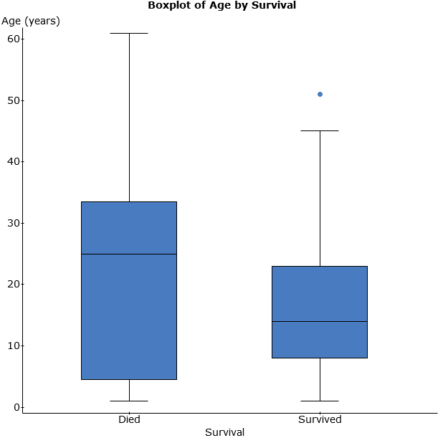

- Obtain the summary statistics of age (mean, median, standard deviation and the interquartile range) of survivors and non-survivors for each gender. Paste the output into your report. What was the difference in average age of those who survived and not survived for each gender?

Summary statistics for Age:
Where: Gender=Male
Group by: Survival
Survival | n | Mean | Std. dev. | Median | IQR
Died | 30 | 24.366667 | 17.662513 | 25 | 25
Survived | 23 | 17.478261 | 13.183563 | 14 | 20

Summary statistics for Age:
Where: Gender=Female
Group by: Survival
Survival | n | Mean | Std. dev. | Median | IQR
Died | 10 | 21.3 | 19.793658 | 18.5 | 43
Survived | 24 | 15.208333 | 10.064916 | 13.5 | 13

The males who survived were an average of 7.3 years younger than those who died, while surviving females averaged 6 years younger than those who died.
- In this question, you will examine the relationship between survival and gender.

- For any given age, were the chances of survival greater for females than for males? In order to answer the question, obtain the contingency table of survival by gender. Make sure that Row percent, Column percent, and Chi-Square options are checked in each contingency table dialog box. Paste the table into your report.

Contingency table results:
Rows: Survival
Columns: Gender
Cell format
Count
(Row percent)
(Column percent)
(Percent of total)

 | Female | Male | Total
Died | 10  (25%)  (29.41%)  (11.49%) | 30  (75%)  (56.6%)  (34.48%) | 40  (100%)  (45.98%)  (45.98%)
Survived | 24  (51.06%)  (70.59%)  (27.59%) | 23  (48.94%)  (43.4%)  (26.44%) | 47  (100%)  (54.02%)  (54.02%)
Total | 34  (39.08%)  (100%)  (39.08%) | 53  (60.92%)  (100%)  (60.92%) | 87  (100%)  (100%)  (100%)
Chi-Square test:
Statistic | DF | Value | P-value
Chi-square | 1 | 6.1659327 | 0.013

- Using α = 0.05, test that there was no relationship between survival and gender. State the null and alternative hypotheses. Report the value of the appropriate test statistic, the distribution of the test statistic under the null hypothesis, and the P-value of the test to answer the question. State your conclusion.

Define the null and alternative hypotheses as follows:

H₀: The survival and gender variables are independent.
H_{A}: The survival and gender variables are dependent.
According to the output, the value of the test statistic is 6.166 and the statistic follows a chi-squared distribution with 1 degree of freedom. According to the output, the P-value of the test is 0.013.
Since the P-value is smaller than α = 0.05, we conclude that there is evidence of a relationship between survival and gender.

- Refer to the output in part (a) to answer the following questions: What percent of the survivors were females? What percent of the Donner party members were females who survived?

There were 24 females among 47 Donner Party members who survived. Therefore 24/47= 51% of survivors were females. 24/87=27.6% of all Donner Party members were females who survived.

- Using α = 0.05, is there evidence that there was a difference in the survival rate for females and males? Carry out the appropriate two-sample proportion test. State the null and alternative hypotheses. Report the value of the appropriate test statistic, the distribution of the test statistic under the null hypothesis, and the P-value of the test to answer the question. State your conclusion.

Two sample proportion hypothesis test:
p₁ : Proportion of successes (Success = Survived) for Survival where Gender=Female
p₂ : Proportion of successes (Success = Survived) for Survival where Gender=Male
p₁ – p₂ : Difference in proportions
H₀ : p₁ – p₂ = 0
H_{A} : p₁ – p₂ ≠ 0
Hypothesis test results:
Difference | Count1 | Total1 | Count2 | Total2 | Sample Diff. | Std. Err. | Z-Stat | P-value
p₁ – p₂ | 24 | 34 | 23 | 53 | 0.27192009 | 0.10950701 | 2.4831296 | 0.013

- What is the relationship between the tests in parts (a) and (b)?

The two tests are equivalent. More precisely, the z-test about the difference in two proportions is equivalent to the chi-squared test for independence when each variable has only two categories. The two tests produce the same P-value and there is the following mathematical relationship between the test statistics: χ² = (z)². Indeed, 6.1659327 ≈ 2.4831296².

- Obtain a 95% confidence interval for the difference in proportions of survivors of females compared to males. Paste the output into your report. What do you conclude? Does it confirm your result in part (b)?

Two sample proportion confidence interval:
p₁ : Proportion of successes (Success = Survived) for Survival where Gender=Female
p₂ : Proportion of successes (Success = Survived) for Survival where Gender=Male
p₁ – p₂ : Difference in proportions
95% confidence interval results:
Difference | Count1 | Total1 | Count2 | Total2 | Sample Diff. | Std. Err. | L. Limit | U. Limit
p₁ – p₂ | 24 | 34 | 23 | 53 | 0.27192009 | 0.10363854 | 0.068792281 | 0.4750479

A 95% confidence interval for the difference in proportions of survivors of females and males is (0.068792281, 0.4750479). The interval does not contain zero, so there is a difference between the proportions. Since both endpoints are positive, the proportion of survivors among females is higher than the proportion of survivors among males. This is consistent with the outcome of the test in part (b).
- In this question, you will explore the relationship between age and survival. First you will divide age into several non-overlapping intervals so that the age of each member falls into exactly one of those age categories. In order to do it, obtain a bin column, Bin(age), for the age variable with the bins starting at 0 and a binwidth of 6 (see “Introductory Lab”, pages 15-16). Make sure that left endpoint of each class interval is included (and that the right endpoint is excluded).

- Obtain a contingency table to study the relationship between survival and Bin(age). Make sure that Row percent, Column percent, and Chi-Square options are checked in each contingency table dialog box. Paste the table into your report. Which age groups were the most likely to have survived and which the least likely to have survived? (Ignore age groups with less than five members.)

Contingency table results:
Rows: Survival
Columns: Bin(Age)
Cell format
Count
(Row percent)
(Column percent)
(Percent of total)

 | 1 to 7 | 7 to 13 | 13 to 19 | 19 to 25 | 25 to 31 | 31 to 37 | 37 to 43 | 43 to 49 | 49 to 55 | 55 to 61 | 61 to 67 | Total
Died | 12  (30%)  (57.14%)  (13.79%) | 2  (5%)  (15.38%)  (2.3%) | 1  (2.5%)  (8.33%)  (1.15%) | 2  (5%)  (28.57%)  (2.3%) | 12  (30%)  (70.59%)  (13.79%) | 4  (10%)  (57.14%)  (4.6%) | 0  (0%)  (0%)  (0%) | 3  (7.5%)  (75%)  (3.45%) | 0  (0%)  (0%)  (0%) | 3  (7.5%)  (100%)  (3.45%) | 1  (2.5%)  (100%)  (1.15%) | 40  (100%)  (45.98%)  (45.98%)
Survived | 9  (19.15%)  (42.86%)  (10.34%) | 11  (23.4%)  (84.62%)  (12.64%) | 11  (23.4%)  (91.67%)  (12.64%) | 5  (10.64%)  (71.43%)  (5.75%) | 5  (10.64%)  (29.41%)  (5.75%) | 3  (6.38%)  (42.86%)  (3.45%) | 1  (2.13%)  (100%)  (1.15%) | 1  (2.13%)  (25%)  (1.15%) | 1  (2.13%)  (100%)  (1.15%) | 0  (0%)  (0%)  (0%) | 0  (0%)  (0%)  (0%) | 47  (100%)  (54.02%)  (54.02%)
Total | 21  (24.14%)  (100%)  (24.14%) | 13  (14.94%)  (100%)  (14.94%) | 12  (13.79%)  (100%)  (13.79%) | 7  (8.05%)  (100%)  (8.05%) | 17  (19.54%)  (100%)  (19.54%) | 7  (8.05%)  (100%)  (8.05%) | 1  (1.15%)  (100%)  (1.15%) | 4  (4.6%)  (100%)  (4.6%) | 1  (1.15%)  (100%)  (1.15%) | 3  (3.45%)  (100%)  (3.45%) | 1  (1.15%)  (100%)  (1.15%) | 87  (100%)  (100%)  (100%)
Chi-Square test:
Statistic | DF | Value | P-value
Chi-square | 10 | 25.908103 | 0.0039

Warning: over 20% of cells have an expected count less than 5.
Chi-Square suspect.

The mortality rate is high for very young children, 1-7 years old (42.86%) after which it decreases. The individuals in the 13-19 age category are the most likely to have survived with the survival rate of 91.67% (followed by 7-13 group with the survival rate of 84.62%). The members of 25-31 years old are the least likely to have survived (ignoring the 43-49 age category consisting of just four individuals; the counts are too small to make any valid conclusions for this class).

Very young children and older individuals are more vulnerable to famine and hypothermia. This is why the mortality is high for young children and older party members.

- Using α = 0.01, test that there was no relationship between survival and age category. Refer to the output in part (a). State the null and alternative hypotheses. Report the value of the appropriate test statistic, the distribution of the test statistic under the null hypothesis, and the P-value of the test to answer the question. State your conclusion.

H₀: The survival and age category variables are independent.
H_{A}: The survival and age category variables are dependent.
According to the output, the value of the test statistic is 25.908103 and the statistic follows a chi-squared distribution with 10 degrees of freedom. According to the output, the P-value of the test is 0.0039. Since the P-value is smaller than α = 0.01, we conclude that there is evidence of a relationship between survival and age. However, the test is not trustworthy because over 20% of cells have an expected count less than 5.

- In this question, you will examine the relationship between survival and group size.

- Obtain the contingency table of survival by group size. Make sure that Row percent, Column percent, and Chi-Square options are checked in each contingency table dialog box. Paste the table into your report. Comment briefly.

Contingency table results:
Rows: Survival
Columns: Group Size
Cell format
Count
(Row percent)
(Column percent)
(Percent of total)

 | 1 | 2 | 3 | 4 | 7 | 9 | 12 | 13 | 16 | Total
Died | 13  (32.5%)  (81.25%)  (14.94%) | 2  (5%)  (50%)  (2.3%) | 1  (2.5%)  (33.33%)  (1.15%) | 5  (12.5%)  (62.5%)  (5.75%) | 0  (0%)  (0%)  (0%) | 0  (0%)  (0%)  (0%) | 5  (12.5%)  (41.67%)  (5.75%) | 6  (15%)  (46.15%)  (6.9%) | 8  (20%)  (50%)  (9.2%) | 40  (100%)  (45.98%)  (45.98%)
Survived | 3  (6.38%)  (18.75%)  (3.45%) | 2  (4.26%)  (50%)  (2.3%) | 2  (4.26%)  (66.67%)  (2.3%) | 3  (6.38%)  (37.5%)  (3.45%) | 6  (12.77%)  (100%)  (6.9%) | 9  (19.15%)  (100%)  (10.34%) | 7  (14.89%)  (58.33%)  (8.05%) | 7  (14.89%)  (53.85%)  (8.05%) | 8  (17.02%)  (50%)  (9.2%) | 47  (100%)  (54.02%)  (54.02%)
Total | 16  (18.39%)  (100%)  (18.39%) | 4  (4.6%)  (100%)  (4.6%) | 3  (3.45%)  (100%)  (3.45%) | 8  (9.2%)  (100%)  (9.2%) | 6  (6.9%)  (100%)  (6.9%) | 9  (10.34%)  (100%)  (10.34%) | 12  (13.79%)  (100%)  (13.79%) | 13  (14.94%)  (100%)  (14.94%) | 16  (18.39%)  (100%)  (18.39%) | 87  (100%)  (100%)  (100%)
Chi-Square test:
Statistic | DF | Value | P-value
Chi-square | 8 | 22.073269 | 0.0048

Warning: over 20% of cells have an expected count less than 5.
Chi-Square suspect.

People travelling alone were the most likely to die in the ordeal: Only 3 out of 16 survived with the survival rate of 18.75%. The survival rate was much higher for people travelling with a spouse or family members. Note that all people travelling on their own were males. It appears that kin group size (lack of social support) played a major role in survivorship of single males. There is no evidence that survival was higher for party members with many social connections as measured by the size of the kin group.

- Using α = 0.01, test that there was no relationship between survival and kin group size. State the null and alternative hypotheses. Report the value of the appropriate test statistic, the distribution of the test statistic under the null hypothesis, and the P-value of the test to answer the question. State your conclusion.

H₀: The survival and kin group size are independent.
H_{A}: The survival and kin group size are dependent.
According to the output, the value of the test statistic is 22.073269 and the statistic follows a chi-squared distribution with 8 degrees of freedom. According to the output, the P-value of the test is 0.0048. Since the P-value is smaller than α = 0.01, we conclude that there is evidence of a relationship between survival and age. However, the outcome of the test is not fully trustworthy because over 20% of cells have an expected count less than 5.

- Briefly summarize the study. In particular, answer the following question: Which factors were the most important predictors of survival? Refer to the statistics obtained in Questions 1-6.

The chance of survival was apparently related to all three factors studied: gender, age, and kin group size. Age category and kin group size (in this particular order) seem to be the most important factors in survival since survival rate was much higher for younger members and also those with social family support. The p-values of the chi-square test of survival and each of age category and kin group size are 0.0039 and 0.0048, respectively. Note that people travelling alone (all males) had a very small chance of survival (18.75%).

Gender is also important factor in survival since survival rate was much higher for females than for males (70.6% vs. 43.4%). The p-value of the test relating survival to gender is not as small as the one relating survival and age category or kin group size.

In summary, age, kin group size and gender are all important predictors for survival, but the importance of the factors appear to be age first, followed by kin group size, and then gender.

LAB 3 ASSIGNMENT: MARKING SCHEMA

Proper header and appearance: 10 points (see cover page format on eClass; labs must be typed)

Question 1 (4)

Observational study or randomized experiment: 2 points
Generalizations to a broader population: 2 points
Causal inferences: 2 points

Question 2 (4)

Number of cases: 1 point
Categorical variables: 2 points
Numerical variables: 1 point

Question 3 (40)

- Frequency table of survival: 2 points
Overall survival rate: 3 points
- Families that lost most of their members: 2 points
- Frequency table of survival by group (alone or family): 2 points
Survival of members travelling alone vs those with family: 2 points
- Frequency table of survival by gender: 2 points
Bar chart of survival for females: 3 points
Bar chart of survival for males: 3 points
Comments: 2 points
- Frequency table of survival of children vs. adults: 2 points
Comments: 2 points
- Summaries of survivors and non-survivors: 2 points
Side-by-side boxplots: 3 points
Comments: 4 points
- Summary statistics of age of survivors and non-survivors for males: 2 points
- Summary statistics of age of survivors and non-survivors for females: 2 points
Comments: 2 points
Question 4 (38)

- Contingency table of survival by gender: 4 points
- Hypotheses: 2 points
The value of the test statistic: 2 points
The distribution of the test statistic under the null hypothesis: 2 points
The P-value: 2 points
Conclusion: 2 points
- Percent of the survivors were females : 2 points
Percent of the Donner party members were females who survived: 2points
- Hypotheses: 2 points
The value of the test statistic: 2 points
The distribution of the test statistic under the null hypothesis: 2 points
The P-value: 2 points
Conclusion: 2 points
- The relationship between the tests in parts (a) and (b): 3 points
- 95% confidence interval: 3 points
Interpretation of the 95% confidence interval: 2 points
Comparison of the confidence interval with the outcome of the test: 2 points

Question 5 (18)

- Contingency table of survival by Bin(age): 4 points
Age groups more likely to have survived: 2 points
Age groups least likely to have survived: 2 points

- Hypotheses: 2 points
The value of the test statistic: 2 points
The distribution of the test statistic under the null hypothesis: 2 points
The P-value: 2 points
Conclusion: 2 points

Question 6 (14)

- Contingency table of survival by group size: 4 points
- Hypotheses: 2 points
The value of the test statistic: 2 points
The distribution of the test statistic under the null hypothesis: 2 points
The P-value: 2 points
Conclusion: 2 points

Question 7 (5)

Summary: 5 points

TOTAL = 133
Created by: Henryk Kolacz;
Edited by: Paul Cartledge
University of Alberta
August, 2017

